**INTERNET & WEB PROGRAMMING (CSE3002)**

**J-COMPONENT PROJECT REPORT**



**BY**

**MAYANK VERMA (15BCE0032)**

**SUBMITTED TO**

**PROF. LYDIA JANE**

**(SCOPE)**

**SCOPE STATEMENT**

**Aim-**This project is directed to make a website for a 10+2 coaching website which helps to manage all student and faculty data

**Objective-**This project aims to build an efficient and effective educational system which causes to create a network amongst the students and the teachers that creates a good environment to work.

**Application-**This helps create and manage account that uphold the database and related information in its portal that is required for the studying and teaching of a specific course.

**FUNCTIONALITY (STUDENT):**

Get registered for taking the classes ->Fill the online form.

Login to the coaching site portal -> Authenticate the credentials.

View and change profile -> update personal details.

View attendance

View grades of the test results

Logout

View recent event details

**UID (STUDENT SIDE):**

**login page:**

For accessing student portal, password and username is needed. If the user does not have an account a link to signup page is also provided.

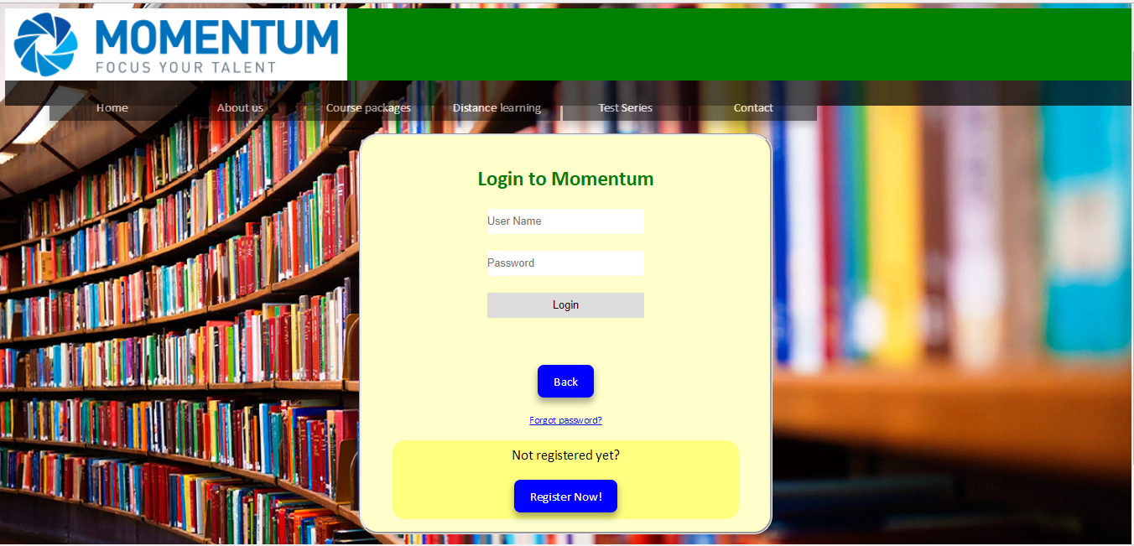

**Registration /signup page:**

To collect all relevant and minimal amount of data required by us to register a new student. Top navigation bar remains static throughout the page to make navigation easy.





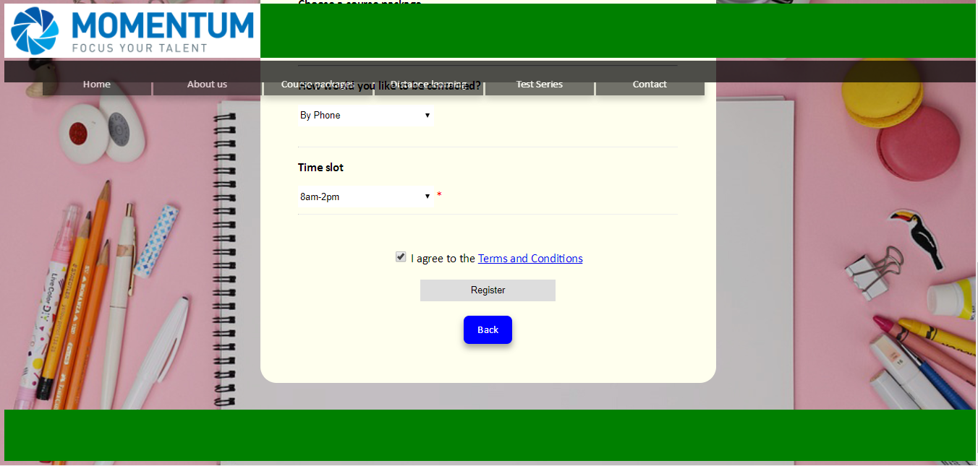

**Student Portal:**

Consists of an iframe in which various functionalities such as attendance, grades, profile, recent events can be displayed. Consists of a logout button which destroys the session and returns user to the login page. All buttons and navigation bars are ststic throughout the portal.

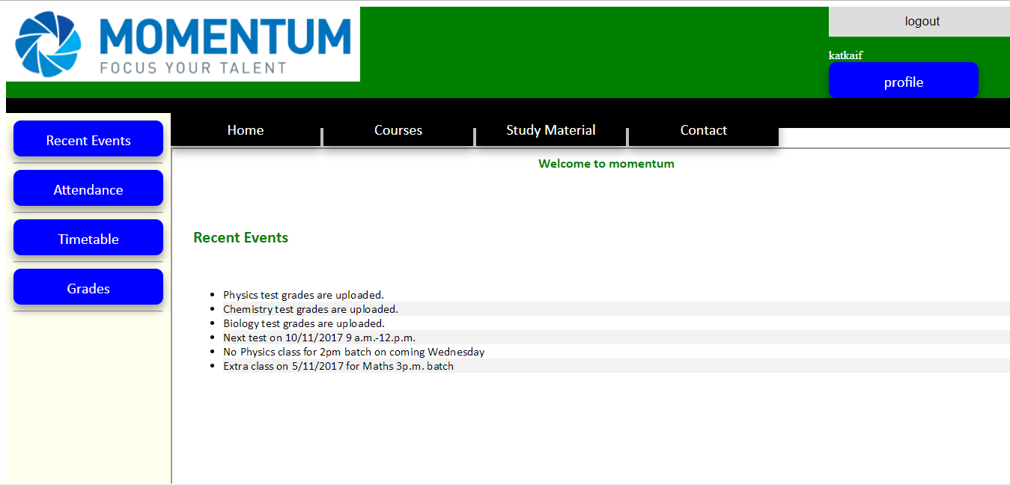

**Attendance:**

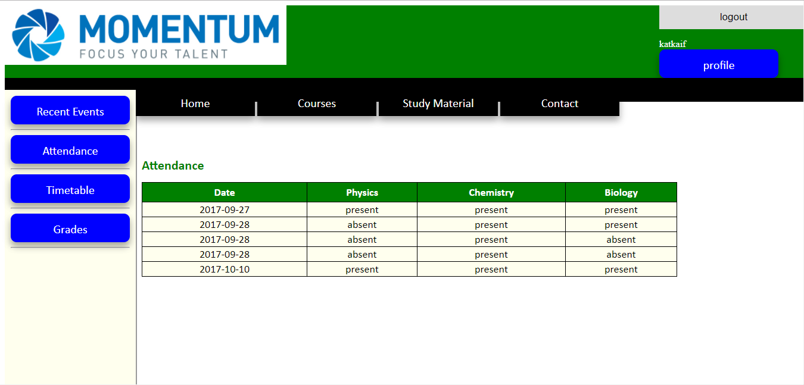

**Grades:**

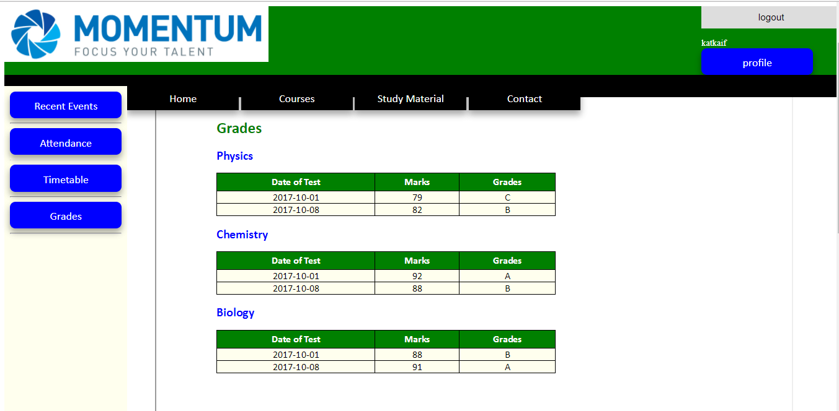

**Profile (view and change):**

The profile can be viewed as well as changed. The phone no. and email are fetched in a text box which can be edited. On clicking the submit button the profile is updated.

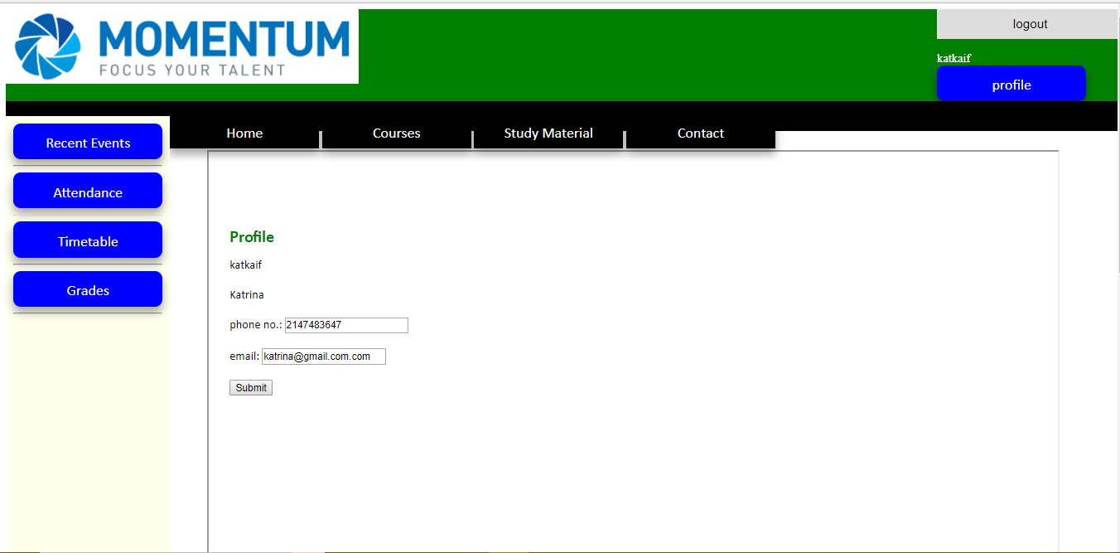

**STUDENT DATABASES STRUCTURE:**

Table Student:

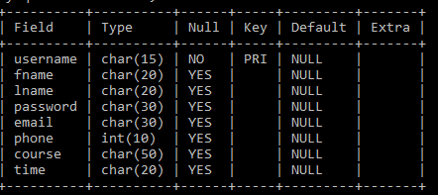

Table attendance:

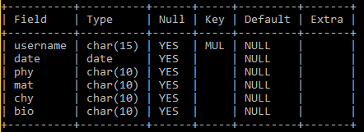

Table for storing test marks:

Table physics:

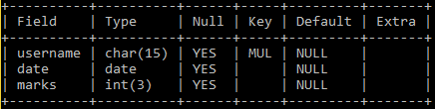

Table chemistry:



Table maths:



Table bio:

